Computer Vision

Assignment - 1

Ahmed Zaki - 7979

Shadi Reda Elattar - 8180

Noureldin Abdelhafez - 8415

Part 1:

**Image Processing Techniques Used**

**Original Image**

The first image is the unedited version of the input image.

**Grayscale Conversion**

The second image is a grayscale version of the original image.

**Median Blur Filtering**

A median blur filter is applied to the grayscale image to remove noise while keeping the edges intact.

**Laplacian Edge Detection**

The Laplacian filter is used to identify edges in the image. It highlights areas where there is a sharp change in intensity, making the outlines and contours more prominent.

**Bilateral Filtering**

Bilateral filtering is applied to smooth the color variations in the image while preserving edges.

**Thresholding**

Thresholding is used to convert the edge-detected image into a binary format, keeping only the most significant edges.

**Cartoon Effect**

The final carbonized image is created by combining the smoothed bilateral-filtered image with the thresholder edge-detected image.

Part 2:

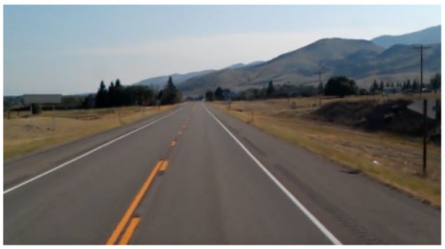

**Lane Detection Using Image Processing**

**Original Image**

The first image shows the unprocessed road scene.

**Grayscale and Median Blur Filtering**

The second image is a grayscale version of the original, which simplifies processing by reducing the color channels. A median blur filter is then applied to remove noise while preserving edges, making lane markings more distinguishable.

**Canny Edge Detection**

Canny edge detection is used to highlight the edges in the image, specifically focusing on the lane markings. This step helps identify strong edges while reducing noise from the surroundings.

**Region of Interest Selection**

A region of interest (ROI) is defined to focus on the road area where lane lines are expected. This eliminates unnecessary details from the background and improves detection accuracy.

**Hough Transform for Line Detection**

The Hough Transform is applied to detect straight lines in the edge-detected image.

**Lane Detection Output**

The final image displays the detected lane lines overlaid on the original road scene. The detected lanes are marked in green, effectively guiding vehicles within their designated path.